### Sec. 10.3. Signs

10.3.1. Applicability

No sign may be erected, altered, refurbished or otherwise modified after the effective date of this UDC except in accordance with the requirements of this UDC.

10.3.2. Sign Permit Required

A. Except as specifically excluded, it is unlawful for any person to post, display, substantially change, or erect a sign or advertising device in the City without first having obtained a sign permit.

B. An application for a sign permit must be filed with the Zoning Director.

10.3.3. Nonconforming Signs

A. A nonconforming sign cannot be replaced by another nonconforming sign, including face material, except that the substitution or interchange of poster panels or painted boards on a nonconforming signs is permitted. All nonconforming signs must be maintained in a safe manner and in good repair.

B. Minor repairs and maintenance of nonconforming signs is permitted. However, no structural repairs, structural changes or changes in the size, shape or technology currently being used on the sign is permitted except to bring the sign out if its nonconforming condition and into compliance with the requirements of this UDC. To the extent that this section is alleged to conflict with O.C.G.A. § 32-6-83 or the Georgia Constitution, this section will provide affected parties the minimum protections provided by O.C.G.A. § 32-6-83 and the Georgia Constitution as both may be amended from time to time.

C. Nonconforming signs may stay in place until one of the following conditions occurs:

1. The business advertised ceases at that location, except that the substitution or interchange of poster panels or painted boards is permitted;

2. The deterioration of the sign makes it a hazard; or

3. The sign has damage exceeding 50% of its replacement cost.

10.3.4. Noncommercial Messages

A. Whenever these sign regulations permit a commercial sign, a noncommercial message may be substituted in lieu of the commercial message.

B. The right to substitute the noncommercial message does not waive any other requirement imposed by this UDC as to number, size, construction, location, lighting, safety or any other regulated attribute.

10.3.5. Prohibited Signs

The following types of signs or advertising devices are prohibited.

A. Any sign constructed and maintained wholly upon or over the roof of a building.

B. Any sign that is not permanently affixed to the ground or to a structure, including but not limited to trailer signs or signs mounted or painted on vehicles which are parked in such a manner as to serve the purpose of an advertising device, except sidewalk signs.

C. Any freestanding sign that sits upon a pylon that is less than 75% of the width of the sign face, does not include a post sign or double-post sign.

D. Rotating or animated signs involving motion or sound.

E. Permanent off-premises signs, except non-illuminated school, hospital, or other quasi-public signs not exceeding 4 square feet in area.

F. Flashing, blinking, or varying light intensity signs.

G. Signs that contain or are an imitation of an official traffic sign or signal.

H. Any reflective or mirrored sign.

I. Pennants, streamers and banners except as allowed in Sec. 10.3.6.

J. Search lights.

K. Human Sign. A sign held by or attached to a human for the purposes of advertising or otherwise drawing attention to an individual, business, commodity, service or product, mere costumes without wording or logos shall not be considered signage.

10.3.6. Temporary Signs

A. **Temporary Sign Permit Required.** The following temporary signs are permitted following issuance of a temporary sign permit.

1. **Promotional Signs.** A temporary sign or attention getting device used to advertise a temporary special event.

a. Air- or gas-filled balloons or other devices that have a capacity for air or gas that does not exceed 3 cubic feet.

b. Flags, signs, pennants, streamers and banners, a maximum size of 32 square feet, except official government flags.

c. Promotional signs can be used for a period not exceeding 10 consecutive days.

d. No temporary sign permit for a promotional sign will be issued for the same premises more than 80 days per year.

e. No business will be issued a promotional sign for more than one sign or device per street frontage to be located on the premises at any one time. Each individual establishment within a multi-tenant center is considered to have one street frontage.

f. No sign can be located within the public right-of-way.

2. **Yard/Garage Sale Sign.** A temporary sign used to advertise a yard/garage sale.

a. No sign can be located within the public right-of-way.

b. Signs must be on private property with the property owner's consent.

c. No sign is allowed on a telephone pole, tree or traffic sign.

d. The maximum size of a sign is 4 square feet per sign.

e. Decals must be attached to each sign.

f. Signs are permitted 2 days prior to sale and must be removed the day after the sale.

g. The temporary sign permit must be displayed upon the request of any municipal officer or citizen requesting identification or proof of permission for the yard/garage sale.

h. A maximum of 6 signs per yard/garage sale are allowed.

i. The temporary sign permit is valid only for family use and may not exceed 3 per year.

j. Additional requirements for yard/garage sales are in Sec. 9.8.3.

3. **Grand Opening Signs.** A temporary sign used to advertise a grand opening or final closing sale.

a. On-premises temporary signs relating to the initial opening or final closing of a business or service are allowed, provided each sign does not exceed 32 square feet each and is not located in the public right-of-way.

b. The Zoning Director can approve signs for a maximum period of 2 weeks for initial opening signs and 4 weeks for final closing signs, after which all signs must be removed.

4. **Farmers' Market.**

a. One temporary banner identifying a city-approved farmers' market with a maximum size of 32 square feet is allowed no more than 24 hours before and 2 hours after the hours of operation for the farmers' market. The banner cannot be located in the public right-of-way.

b. Additional requirements for Farmers' Market are in Sec. 9.7.7.

5. **Off-Site Real Estate Directional Signs.** A temporary sign erected by the owner, or their agent, conveying the route to real property, but not located on the property itself.

a. Signs are allowed for a maximum period of 2 consecutive days in any one week.

b. A maximum of 3 signs per house/lot are allowed.

c. Signs must be located within 2 miles of the property to which they refer, as measured along existing streets.

d. No sign can be located within the public right-of-way.

e. Signs cannot exceed a maximum area of 4 square feet per sign.

f. Not more than 1 sign is allowed at any "T" intersection and no more than 2 signs are allowed at any 4-way intersection.

g. Signs cannot have any balloons, streamers, and pennants attached to them.

h. Such signs cannot be illuminated.

i. Signs can only be placed on property with the owner's express written permission.

6. **On-Site Real Estate Signs.** A temporary sign erected by the owner, or their agent, advertising the real property upon which the sign is located for rent, lease, or for sale.

a. **Single-Family Residential District.**

i. Only one sign is permitted per lot or home for sale.

ii. The sign cannot be illuminated.

iii. The sign cannot exceed 6 square feet in area.

iv. Signs must be removed within 10 days after the lot or building is leased, or sold.

v. Signs cannot be located within the public right-of-way.

b. **All Other Districts.**

i. Only 1 sign is permitted per parcel for sale or lease, except that corner lots may have 1 sign per frontage, separated by not less than 50 feet.

ii. Once the building is occupied, no on-site real estate signs are allowed on the ground; they must be located on a panel on an existing monument sign or placed in the window of an empty tenant space.

iii. The sign cannot be illuminated.

iv. Each sign cannot exceed 32 square feet in area and 10 feet in height.

v. Signs must be removed within 10 days after the lot or building is leased, or sold.

vi. Signs cannot be located within the public right-of-way

7. **Construction Sign.** A temporary sign erected and maintained on premises for a proposed construction project.

a. Only 1 sign is permitted per lot or parcel, except that corner lots may have 1 sign per frontage, separated by not less than 50 feet.

b. Each sign cannot exceed 32 square feet in area and 10 feet in height.

c. Signs cannot be illuminated.

d. Signs may be erected once the first development permit for the project has been issued. If development is not begun in 60 days or if construction is not continuously and actively pursued to completion, all signs must be removed.

e. Signs must be removed upon completion of the project or when the development permit expires.

f. Signs cannot be located within the public right-of-way.

g. Construction Fence Wraps

1. Wraps are allowed on fences securing new construction sites for the duration of the construction activity.

2. The wrap must be removed prior to the issuance of a Certificate of Occupancy.

3. The fence wrap must be maintained in good condition and be properly attached to the fence.

4. Messages, logos, renderings or similar information shall not exceed 30 percent of the total fence wrap area.

B. **Temporary Signs Not Requiring a Permit.** The following temporary signs are allowed without the issuance of a temporary sign permit, provided they meet the specified standards below.

1. **Political Signs.** A sign identifying or urging voter support for a particular election issue, political party, or candidate for public office. A political sign cannot exceed 32 square feet in area and 8 feet in height.

2. **Civic or Educational Institutions.** Temporary signs not exceeding 4 feet in area pertaining to drives or events of civic, philanthropic, educational, religious organizations are allowed, provided signs are posted not more than 2 days before the event and removed the day after the event.

3. **New and Used Automobile Sales.**

a. New and used automobile sales establishments may display 8-inch vinyl letters professionally made, not hand lettered, indicating the price, model and year of vehicles for sale on the front windshield, not to exceed a total of 320 square inches of area per vehicle.

b. Establishments are allowed to use 2 of the following 3 colors: non-fluorescent white, pastel blue and yellow.

c. Vehicles must set back at least 15 feet from the edge of pavement of the public street.

(Ord. No. 2019-08-26 , §§ 1, 2, 8-26-2019)

10.3.7. Signs Not Requiring a Permit

The following types of signs are exempt from Sec. 10.3.6 and Sec. 10.3.8.

A. **Public Interest Signs.** Signs of a noncommercial nature and in the public interest, erected by or on the order of a public officer in the performance of their duty, such as public notices, safety sign, danger signs, trespassing signs, traffic and street signs, memorial plaques and signs of historical interest.

B. **Traffic Movement Signs on Private Property.** Signs on private property directing traffic movement, not exceeding 3 square feet in area, and not advertising any business, service or product. Signs cannot be located within the public right-of-way.

C. **Credit Card Identification Signs.** On-premises credit card identification signs up to 3 square feet in total area, located on the building of the business to which they relate.

D. **Signs not Visible from the Public Right-of Way.** Any sign not visible from a public street.

E. **Window Signs.**

1. A sign installed inside a window for purposes of viewing from outside the premises. Signs cannot exceed 30% of the window area.

2. An exposed neon window sign stating "open" that is not greater than 5 square feet in area and does not exceed 30% of the window area, limited to 1 per establishment. Neon signs are not allowed in the -HOD or -PV districts.

F. **Quasi-Public Signs.** Off-premises non-illuminated school, hospital, or other quasi-public signs not exceeding 4 square feet in area. Signs cannot be located within the public right-of-way.

G. **Public Notice Signs.** On-premises warning or similar public notice type signs not exceeding 6 square feet in area. Signs cannot be located within the public right-of-way. Signs can be placed no closer than 100 feet from one another.

H. **Flags.** Any fabric or other flexible material containing distinctive colors, patterns or symbols used to identify a local, state, or national government or private organization designed to be flown from a flagpole.

1. A maximum of 3 of the following flags are permitted per lot or site:

a. The official flag of The United States of America;

b. Any official flag of a state or territory of the United States of America;

c. Any official flag adopted by a member state of the United Nations;

d. Any official flag adopted by a sovereign nation, including Switzerland; and

e. Any flag that contains the official logo or trademarked symbol of the business, entity or development on which the flagpole is located.

2. An individual flag cannot exceed 60 square feet in area.

3. The maximum height of a flagpole is 40 feet, measured from the highest point of the flagpole to the top of the abutting sidewalk or parking area.

4. A flagpole must be set back from a property line a distance equal to the height of the pole. For example, a flagpole 40 feet in height must be set back at least 40 feet from a property line.

I. **Murals.** A mural or work of visual art that conforms with the following standards:

1. Is located on the wall of a building in any district, except a Residential District;

2. Includes no text legible from a public right-of-way;

3. Includes no logo or trademarked symbol;

4. Includes no specific commercial product, although it may include generic products such as automobiles, furniture, soft drinks or other items where the brand is not apparent; and

5. Includes no picture, symbol or device of any kind that relates to a commercial business, product or service offered on the premises where the wall is located.

J. **One Percent Rule.** On premise signs attached to the outside wall of any business establishment, which are designed to identify services rendered, products sold or activities conducted on the premises are allowed provided:

1. The total area of such signs does not exceed 1% of the total area of the wall on which they are affixed; and

2. No more than two such signs are allowed per building.

10.3.8. Signs in the Right-of-Way

A. Ground signs, subdivision entrance signs, double post signs and single post signs cannot encroach into the public right-of way.

B. Wall signs, awning signs, canopy signs, projecting signs, crown signs, shingle signs and sidewalk signs may encroach over the public sidewalk but not over any public street, parking area, driveway or alley. All signs must be a minimum of 18 inches inside the curb line or edge of pavement, whichever is greater.

10.3.9. Signs Requiring a Permit

Signs are allowed by district as set forth below. Specific requirements for each sign are shown on the following pages. All of the following sign types require a sign permit.

|  |  |  |  |  |  |  |  |  |  |  |  |  |  |  |  |  |  |  |  |  |  |  |  |
| --- | --- | --- | --- | --- | --- | --- | --- | --- | --- | --- | --- | --- | --- | --- | --- | --- | --- | --- | --- | --- | --- | --- | --- |
|  | **Residential** | | | | | | | | | | | | | | | | | | | | | | Standards |
| **AG-43** | **RS-87** | | **RS-30** | **RS-18** | **RS-12** | | **RS-9** | | **RS-6** | **R-S4** | | **R-CC** | | **R-TF** | | **R-TH** | | **RM-2** | | **RM-3** | |
| Wall Sign | — | — | — | | — | — | — | | — | | — | — | | — | | — | | — | | — | | Sec. 10.3.10 | |
| Awning Sign | — | — | — | | — | — | — | | — | | — | — | | — | | — | | — | | — | | Sec. 10.3.11 | |
| Canopy Sign | — | — | — | | — | — | — | | — | | — | — | | — | | — | | — | | — | | Sec. 10.3.12 | |
| Projecting Sign | — | — | — | | — | — | — | | — | | — | — | | — | | — | | — | | — | | Sec. 10.3.13 | |
| Crown Sign | — | — | — | | — | — | — | | — | | — | — | | — | | — | | — | | — | | Sec. 10.3.14 | |
| Shingle Sign | — | — | — | | — | — | — | | — | | — | — | | — | | — | | — | | — | | Sec. 10.3.15 | |
| Ground Sign | — | — | — | | — | — | — | | — | | — | — | | — | | — | | — | | — | | Sec. 10.3.16 | |
| Subdivision Entrance Sign | ● | ● | ● | | ● | ● | ● | | ● | | ● | ● | | ● | | ● | | ● | | ● | | Sec. 10.3.17 | |
| Subdivision Community Information Sign | ● | ● | ● | | ● | ● | ● | | ● | | ● | ● | | ● | | ● | | ● | | ● | | Sec. 10.3.18 | |
| Double Post Sign | ▲ | — | — | | — | — | — | | — | | — | — | | — | | — | | — | | — | | Sec. 10.3.19 | |
| Single Post Sign | ▲ | — | — | | — | — | — | | — | | — | — | | — | | — | | — | | — | | Sec. 10.3.20 | |
| Sidewalk Sign | ▲ | — | — | | — | — | — | | — | | — | — | | — | | — | | — | | — | | Sec. 10.3.21 | |

KEY:   
 ● = Sign type allowed   
 ▲ = Allowed sign type for nonresidential uses only   
 — = Sign type not allowed

|  |  |  |  |  |  |  |  |  |  |  |  |  |  |  |  |  |  |  |  |  |  |  |  |  |  |  |  |  |  |  |  |  |  |
| --- | --- | --- | --- | --- | --- | --- | --- | --- | --- | --- | --- | --- | --- | --- | --- | --- | --- | --- | --- | --- | --- | --- | --- | --- | --- | --- | --- | --- | --- | --- | --- | --- | --- |
|  | **Corridors and Nodes** | | | | | | | | | | | | | | **Downtown** | | | | **Employment** | | | | | | | **Civic/Open Space** | | | | | | | Standards |
| **RX-** | | **NX-** | | **CX-** | | **SH-** | | **CC-** | | **PV-** | | **CH-** | | **DR-** | **DX-** | **DS-** | **DH-** | **OR-** | | **OP-** | | **IX-** | | **IL-** | | **CIV** | | **REC** | | **CON** | |
| Wall Sign | | ▲ | | ● | | ● | | ● | | ● | | ● | | ● | ▲ | ● | ● | ● | ● | ● | | ● | | ● | | ● | | ● | | — | | Sec. 10.3.10h | |
| Awning Sign | | — | | ● | | ● | | ● | | ● | | ● | | ● | — | ● | ● | ● | ● | ● | | ● | | ● | | — | | — | | — | | Sec. 10.3.11 | |
| Canopy Sign | | — | | ● | | ● | | ● | | ● | | ● | | ● | — | ● | ● | ● | ● | ● | | ● | | ● | | — | | — | | — | | Sec. 10.3.12 | |
| Projecting Sign | | — | | ● | | ● | | ● | | ● | | ● | | ● | — | ● | — | — | ● | ● | | ● | | ● | | ● | | — | | — | | Sec. 10.3.13 | |
| Crown Sign | | — | | — | | ● | | ● | | ● | | ● | | ● | — | — | — | — | ● | ● | | ● | | — | | — | | — | | — | | Sec. 10.3.14 | |
| Shingle Sign | | — | | ● | | ● | | ● | | — | | — | | — | — | ● | ● | ● | — | — | | — | | — | | — | | — | | — | | Sec. 10.3.15 | |
| Ground Sign | | — | | ● | | ● | | — | | ● | | ● | | ● | — | ● | — | — | ● | ● | | ● | | ● | | ● | | — | | — | | Sec. 10.3.16 | |
| Subdivision Entrance Sign | | ● | | ● | | ● | | — | | ● | | ● | | ● | ● | ● | — | — | ● | ● | | ● | | ● | | — | | — | | — | | Sec. 10.3.17 | |
| Subdivision Community Information Sign | | ● | | ● | | ● | | — | | — | | ● | | — | — | — | — | — | — | — | | — | | — | | — | | — | | — | | Sec. 10.3.18 | |
| Double Post Sign | | — | | ● | | ● | | — | | ● | | ● | | ● | — | ● | — | ● | ● | ● | | ● | | ● | | ● | | ● | | — | | Sec. 10.3.19 | |
| Single Post Sign | | — | | ● | | ● | | — | | ● | | ● | | ● | — | ● | — | ● | ● | ● | | ● | | ● | | ● | | ● | | — | | Sec. 10.3.20 | |
| Sidewalk Sign | | — | | — | | — | | — | | — | | — | | — | — | ● | ● | ● | — | — | | — | | — | | — | | — | | — | | Sec. 10.3.21 | |

KEY:   
 ● = Sign type allowed   
 ▲ = Allowed sign type for nonresidential uses only   
 — = Sign type not allowed

10.3.10. Wall Sign





|  |
| --- |
| Description |
| A sign applied to or mounted to the wall or surface of a building or structure, the display surface of which does not project more than 12 inches from the outside wall of the building or structure. |
| General Provisions |
| 1. A wall sign must be placed no higher than 18 feet above the sidewalk. |
| 2. No portion of a wall sign may extend above the roof line or above a parapet wall of a building with a flat roof. |
| 3. No portion of a wall sign may extend above the lower eave line of a building with a pitched roof. |
| 4. A wall sign cannot cover windows or architectural details. |
| 5. Channel letters are not allowed in a Downtown Historic District. |
| 6. A wall sign can be externally or internally illuminated in accordance with Sec. 10.3.24. |

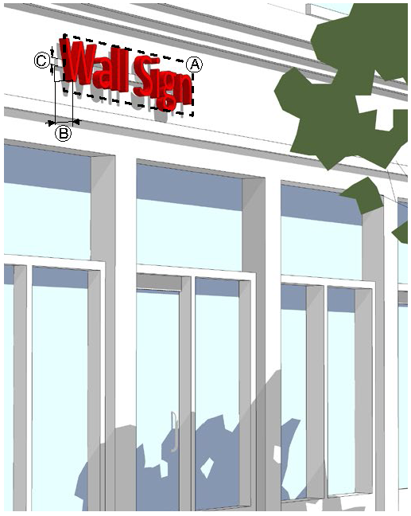

|  |  |  |
| --- | --- | --- |
| Total Sign Area Allocation | | |
| 1 SF of sign area per linear foot of store frontage or 32 SF if the store frontage is less than 32 feet wide. This allocation includes area allocated for awning signs, canopy signs and projecting signs. Area allocation may be divided between all allowable wall signs. | | |
| Dimensions | | |
| Ⓐ | Sign area (max) |  |
|  | DS- | 32 SF* |
|  | RX-, DR-, DX-, DH-, REC | 32 SF |
|  | NX-, OR-, OP- | 50 SF |
|  | PV- | 96 SF |
|  | All other districts | 128 SF |
| Ⓑ | Projection - measured from building facade (max) | 12" |
| Ⓒ | Raceway (max % of letter height) | — |
| Number of Signs | | |
| A business may have a maximum of two wall signs. | | |

* For buildings with a store frontage of more than 30 linear feet. All other buildings may have a wall sign of 18 square feet.

(Ord. No. 2019-04-17 , § 1, 4-8-2019; Ord. No. 2020-03-04 , § 1, 3-9-2020)

10.3.11. Awning Sign





|  |
| --- |
| Description |
| A sign where graphics or symbols are painted, sewn, or otherwise adhered to the awning material as an integrated part of the awning itself. |
| General Provisions |
| 1. An awning sign cannot extend outside the awning. |
| 2. Only awnings over ground story doors or windows may contain signs. |
| 3. An awning sign may only be externally illuminated in accordance with Sec. 10.3.24. |

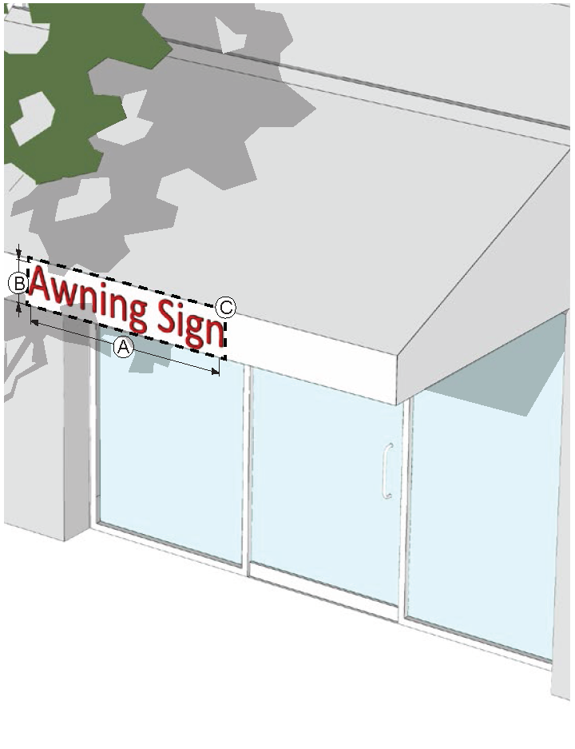

|  |  |  |
| --- | --- | --- |
| Total Sign Area Allocation | | |
| 1 SF of sign area per linear foot of store frontage or 32 SF if the store frontage is less than 32 feet wide. This allocation includes area allocated for canopy signs, projecting signs and wall signs. | | |
| Dimensions | | |
| Ⓐ | Width (max % of awning width/depth) | 75% |
| Ⓑ | Height of text and graphics on valance (max) | 2' |
| Ⓒ | Area (max) - DS- only | 9 SF |
| Number of Signs | | |
| A maximum of one awning sign is allowed per awning. A sign can be on either the front or side valance. Signs are not allowed on the sloping face of the awning. | | |

10.3.12. Canopy Sign



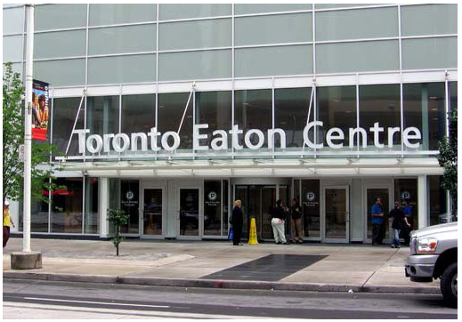

|  |
| --- |
| Description |
| A sign placed on a canopy so that the display surface is parallel to the plane of the front building facade. |
| General Provisions |
| 1. A canopy sign cannot extend outside the overall length or width of the canopy. However, a canopy sign may extend above or below the canopy. |
| 2. Raceways are permitted for signs extending below or above the canopy. Otherwise, raceways are not permitted and the sign must be flush with the canopy face. |
| 3. A canopy sign can be externally or internally illuminated in accordance with Sec. 10.3.24. |

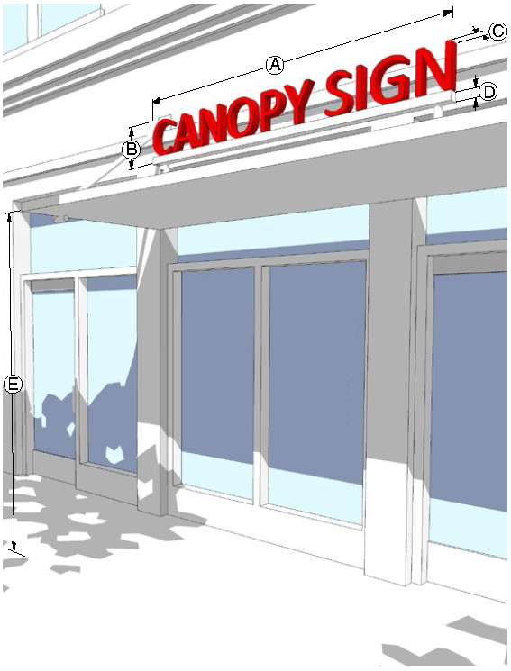

|  |  |  |
| --- | --- | --- |
| Total Sign Area Allocation | | |
| 1 SF of sign area per linear foot of store frontage or 32 SF if the store frontage is less than 32 feet wide. This allocation includes area allocated for awning signs, projecting signs and wall signs. | | |
| Dimensions | | |
| Ⓐ | Width (max % of canopy width) | 75% |
| Ⓑ | Height of text and graphics (max) | 2' |
| Ⓒ | Depth (max) | 1' |
| Ⓓ | Raceway (max % of letter height) | — |
| Ⓔ | Clear height above sidewalk if sign extends below canopy (min) | 10' |
| Number of Signs | | |
| A maximum of one sign is allowed per canopy. | | |

10.3.13. Projecting Sign

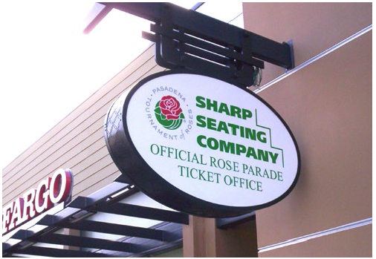

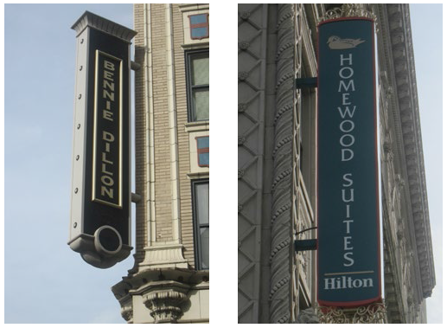

|  |
| --- |
| Description |
| A sign applied to or mounted to the wall or surface of a building or structure, the display surface of that projects 12 inches or more from the outside wall of the building or structure. |
| General Provisions |
| 1. A projecting sign may be erected on a building corner when the building corner adjoins the intersection of two streets. Allocation of sign area from both streets may be used, however, in no case can the sign exceed the maximum height and width standards. |
| 2. The top of a projecting sign can be no higher than the top of the building. However, on one-story buildings, the top of a projecting sign may have a maximum of 20% of the sign height above the top of the building. |
| 3. Buildings 4 stories and higher, a projecting sign must be located below the window sills of the 4th story. |
| 4. A projecting sign can be externally or internally illuminated in accordance with Sec. 10.3.24. |

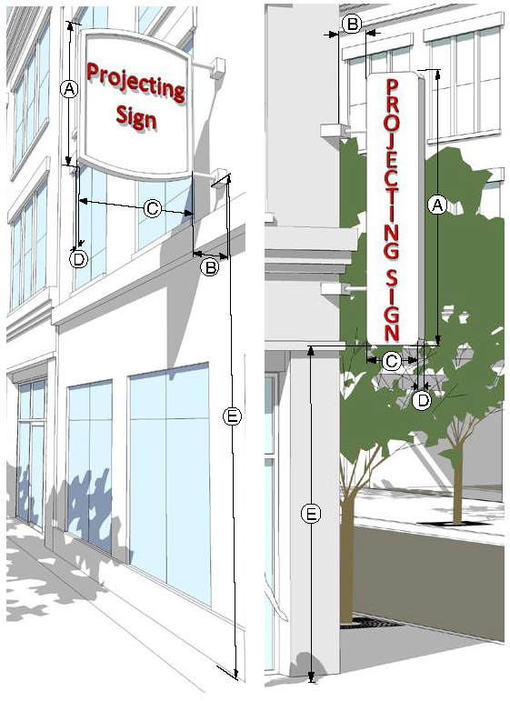

|  |  |  |
| --- | --- | --- |
| Total Sign Area Allocation | | |
| 1 SF of sign area per linear foot of store frontage or 32 SF if the store frontage is less than 32 feet wide. This allocation includes area allocated for awning signs, canopy signs and wall signs. | | |
| Dimensions | | |
| Ⓐ | Height (max) |  |
|  | Mounted below 2nd floor | 4' |
|  | Mounted between 2nd and 3rd floor | 8' |
|  | Mounted above 3rd floor | 12' |
| Ⓑ | Spacing from building facade (min/max) | 1'/2' |
| Ⓒ | Projection width (max) | 6' |
| Ⓓ | Depth (max) | 1' |
| Ⓔ | Clear height above sidewalk (min) | 10' |
| Number of Signs | | |
| 1. | Maximum of one projecting sign or shingle sign per individual establishment per public street frontage. | |
| 2. | A projecting sign must be located at least 25 feet from any other projecting sign or shingle sign. | |

10.3.14. Crown Sign





|  |
| --- |
| Description |
| A wall sign extending not more than 3 feet from the building facade located on the upper horizontal band of a building at least 55 feet and 4 stories in height. |
| General Provisions |
| 1. A crown sign is only allowed on buildings at least 55 feet or 4 stories in height. |
| 2. A crown sign cannot be placed below the start of the highest floor and cannot extend above the roof line. |
| 3. A crown sign cannot cover windows or architectural details. |
| 4. A crown sign can only be internally illuminated in accordance with Sec. 10.3.24. |

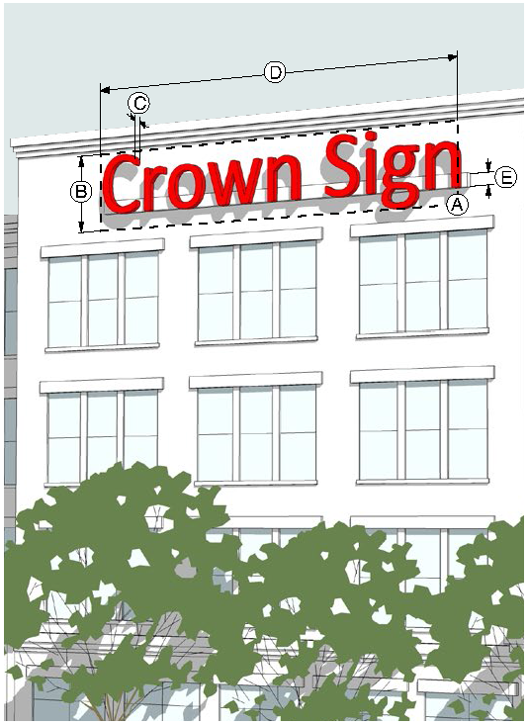

|  |  |  |
| --- | --- | --- |
| Dimensions | | |
| Ⓐ | Sign area (max per sign) | 250 SF |
| Ⓑ | Height (max) | 8' |
| Ⓒ | Projection - measured from building facade (max) | 3' |
| Ⓓ | Width (max % of facade width) | 75% |
| Ⓔ | Raceway (max % of letter height) | — |
| Number of Signs | | |
| 1. | No more than one crown sign per building facade and no more than 2 crown signs per building are allowed. | |
| 2. | No more than one tenant can be identified on the sign. | |

10.3.15. Shingle Sign



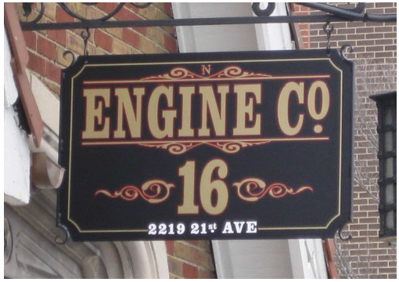

|  |
| --- |
| Description |
| A small projecting sign that hangs from a bracket or support and is located over or near a building entrance. |
| General Provisions |
| 1. A shingle sign must be located within 5 feet of an accessible building entrance. |
| 2. The hanging bracket must be an integral part of the sign design. |
| 3. A shingle sign must be located below the window sills of the second story on a multi-story building or below the roof line on a single-story building. |
| 4. A shingle sign cannot be illuminated. |

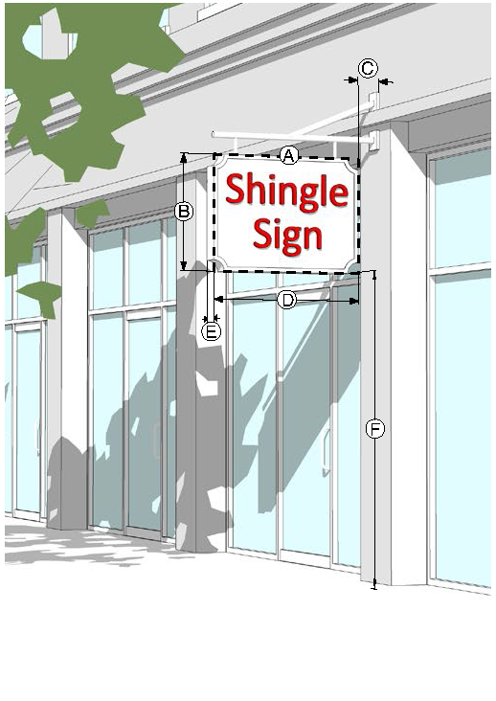

|  |  |  |
| --- | --- | --- |
| Dimensions | | |
| Ⓐ | Sign area (max per sign) | 9 SF |
| Ⓑ | Height (max) | 3' |
| Ⓒ | Spacing from building facade (min/max) | 6"/12" |
| Ⓓ | Projection width (max) | 3' |
| Ⓔ | Depth (max) | 6" |
| Ⓕ | Clear height above sidewalk (min) | 10' |
| Number of Signs | | |
| 1. | Maximum of one shingle sign or projecting sign per individual establishment per street frontage. | |
| 2. | No tenant can have more than one shingle sign per street frontage. | |

10.3.16. Ground Sign



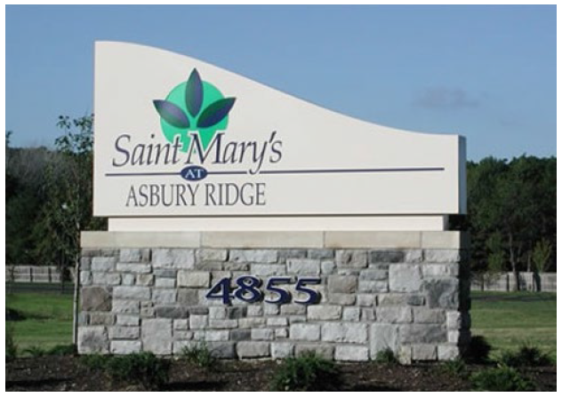

|  |
| --- |
| Description |
| A permanently affixed sign which is wholly independent of a building for support attached along its entire width to a continuous pedestal. |
| General Provisions |
| 1. Ground signs located within 100 feet of a public right-of-way must display the street address of the property. Where multiple addresses exist, the highest and lowest street address numbers must be identified. This provision does not apply to any ground sign where the sign is located on property which has more than one street frontage and the property address is assigned from a street other than the street frontage where the ground sign is erected. Numbers must be a minimum of 8 inches in height and be visible from both directions of travel. |
| 2. A ground sign must be set back at least 10 feet from the front lot line and 15 feet from a side lot line. |
| 3. A ground sign can be externally or internally illuminated in accordance with Sec. 10.3.24. |

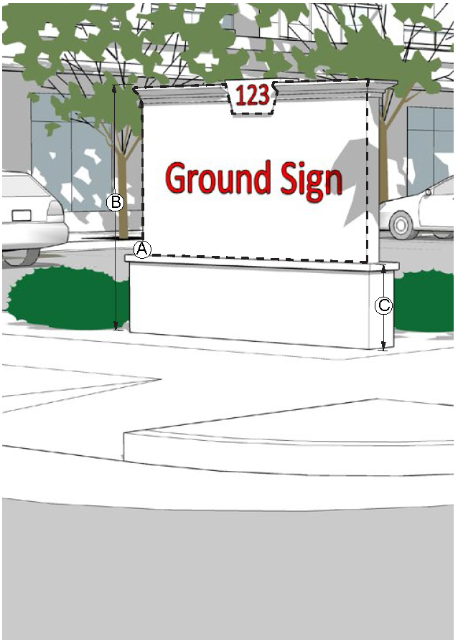

|  |  |
| --- | --- |
| Dimensions | |
| Ⓐ Sign area (max per sign) |  |
| -HOD, -PV | 48 SF |
| All other districts - by number of tenants |  |
| 1 tenant | 50 SF |
| 2 to 3 tenants | 64 SF |
| 4 to 5 tenants | 72 SF |
| 6 or more tenants | 96 SF |
| Ⓑ Height (max) |  |
| -HOD, -PV | 8' |
| All other districts | 12' |
| Ⓒ   Sign base height (min/max) | 2'/5' |
| Number of Signs | |
| 1. Only one ground sign or double post sign is allowed per street frontage, except that one additional sign is allowed for properties with 1,000 feet or more of street frontage, provided all signs are conforming. | |
| 2. Where more than one ground sign or double post sign is allowed, signs along the same street frontage must be spaced a minimum of 500 feet apart. | |

10.3.17. Subdivision Entrance Sign

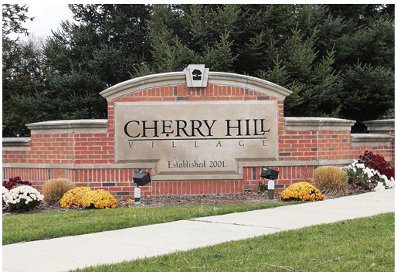



|  |
| --- |
| Description |
| A permanently affixed sign which is wholly independent of a building for support attached along its entire width to a continuous pedestal that is used to identify entry to a development. |
| General Provisions |
| 1. A subdivision entrance sign must be set back at least 10 feet from the front property line and 15 feet from a side property line. |
| 2. A subdivision entrance sign can be externally or internally illuminated in accordance with Sec. 10.3.24. |
| 3. A subdivision entrance sign must not conflict with the required sight triangle (see Sec. 11.4.6). |

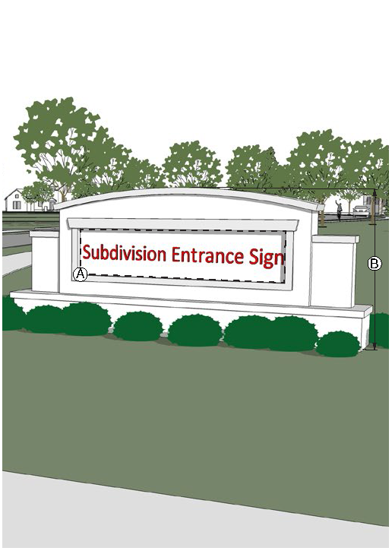

|  |  |  |
| --- | --- | --- |
| Dimensions | | |
| Ⓐ | Sign area (max per sign) | 32 SF |
| Ⓑ | Height (max) | 8' |
| Number of Signs | | |
| Two subdivision entrance signs are allowed per street frontage, one on each side of the entrance to the subdivision. | | |

10.3.18. Subdivision Community Information Sign

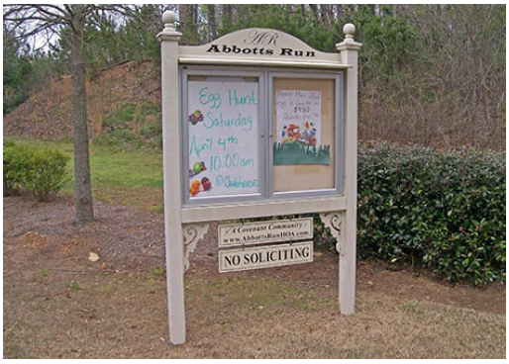

|  |
| --- |
| Description |
| A permanent ground sign used to provide a non-commercial message for the residential community in which the sign is located. |
| General Provisions |
| 1. A subdivision community information sign must be for the subdivision only and cannot be used in any manner for advertisement. |
| 2. A subdivision community information sign can be externally or internally illuminated in accordance with Sec. 10.3.24. |

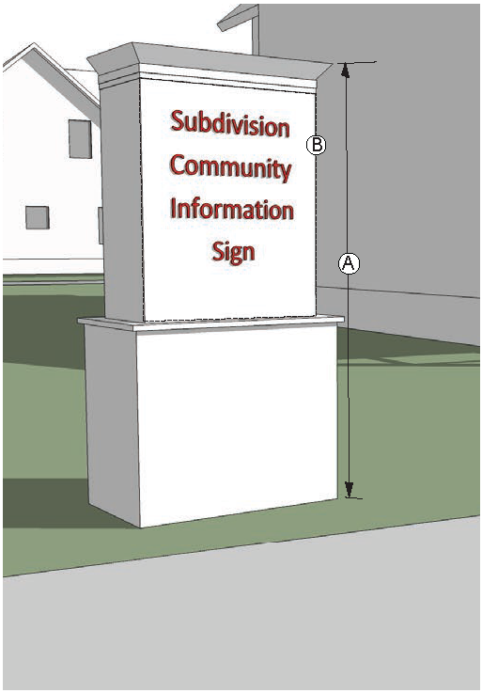

|  |  |
| --- | --- |
| Dimensions | |
| Ⓐ Sign area (max per sign) | 24 SF |
| Ⓑ Height (max) | 7' |
| Setback from exterior of subdivision | 50' |
| Number of Signs | |
| One sign is allowed per main subdivision entrance. | |

10.3.19. Double Post Sign

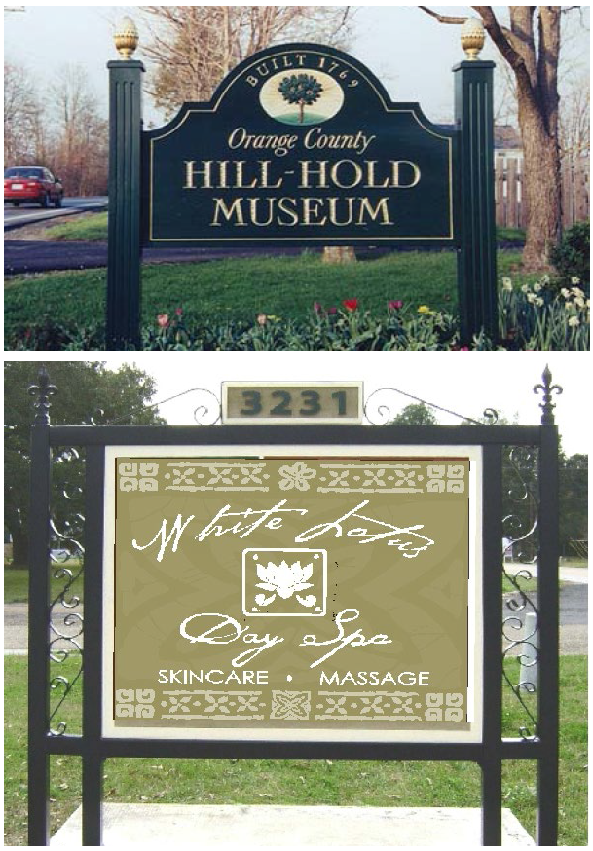

|  |
| --- |
| Description |
| A permanently affixed sign which is wholly independent of a building for support where the primary support is supplied by two posts positioned no more than 2 inches from the outer edge of the sign face. |
| General Provisions |
| 1. Double post signs located within 100 feet of a public right-of-way must display the street address of the property. Where multiple addresses exist, the highest and lowest street address numbers must be identified. This provision does not apply to any ground sign where the sign is located on property which has more than one street frontage and the property address is assigned from a street other than the street frontage where the ground sign is erected. Numbers must be a minimum of 8 inches in height and be visible from both directions of travel. |
| 2. A double post sign must be set back at least 10 feet from the front lot line and 15 feet from a side lot line. |
| 3. A double post sign can only be externally illuminated in accordance with Sec. 10.3.24. |

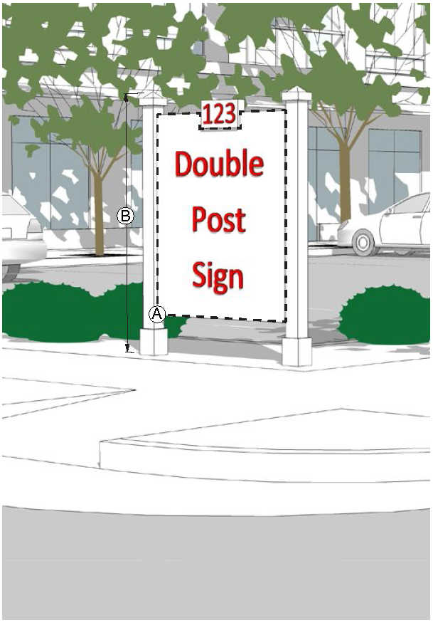

|  |  |
| --- | --- |
| Dimensions | |
| Ⓐ Sign area (max per sign) |  |
| DH- | 36 SF |
| All other districts | 48 SF |
| Ⓑ Height (max) |  |
| DH- | 6' |
| All other districts | 8' |
| Number of Signs | |
| 1. Only one ground sign or double post sign is allowed per street frontage, except that one additional sign is allowed for properties with 1,000 feet or more of street frontage, provided all signs are conforming. | |
| 2. Where more than one ground sign or double post sign is allowed, signs along the same street frontage must be spaced a minimum of 500 feet apart. | |

10.3.20. Single Post Sign

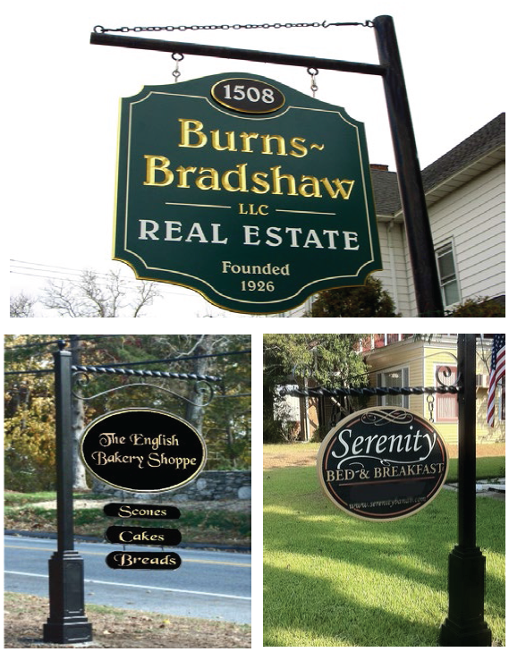

|  |
| --- |
| Description |
| A permanently affixed sign which is wholly independent of a building for support where the primary support is supplied by a post and where the sign hangs from a bracket or support. |
| General Provisions |
| 1. A single post sign must be set back at least 5 feet from the front lot line and 5 feet from a side lot line. |
| 2. The hanging bracket must be an integral part of the sign design. |
| 3. A single post sign can only be externally illuminated in accordance with Sec. 10.3.24. |

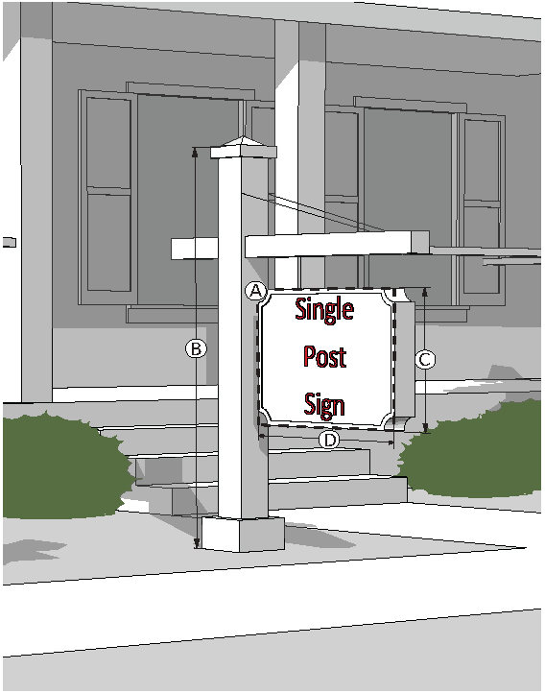

|  |  |
| --- | --- |
| Dimensions | |
| Ⓐ Sign area (max per sign) | 9 SF |
| Ⓑ Structure height (max) |  |
| -HOD, PV- | 9' |
| All other districts | 12' |
| Ⓒ Sign height (max) | 5' |
| Ⓓ Sign width (max) | 3' |
| Number of Signs | |
| 1. Only one single post sign is allowed per building. | |
| 2. A single post sign must be located at least 25 feet from any other single post sign. | |

10.3.21. Sidewalk Sign

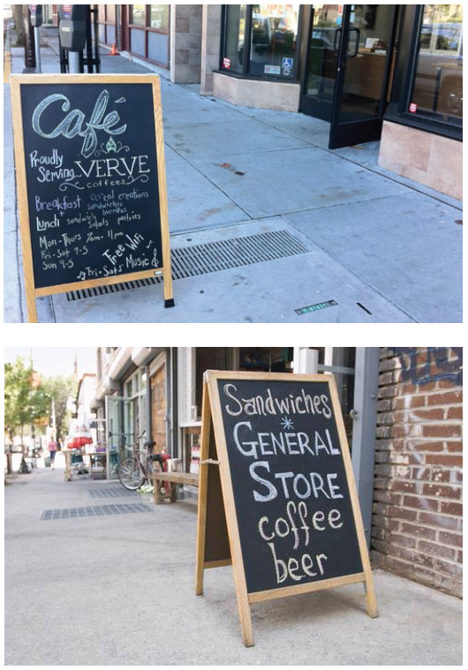

|  |
| --- |
| Description |
| A movable sign not secured or attached to the ground or surface upon which it is located. |
| General Provisions |
| 1. Sidewalk signs must be removed and placed indoors at the close of business each day. |
| 2. Sidewalk signs cannot obstruct vehicular, bicycle or pedestrian traffic and must comply with ADA clearance and accessibility. |
| 3. A sidewalk sign cannot be illuminated. |

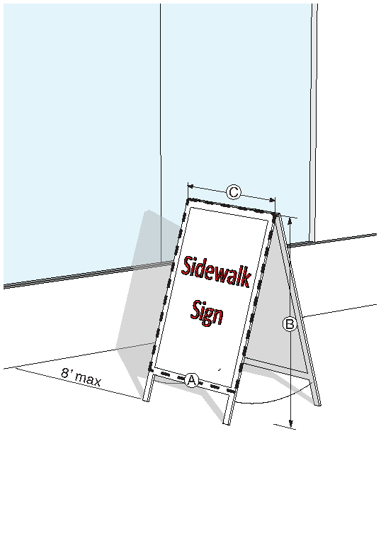

|  |  |
| --- | --- |
| Dimensions | |
| Ⓐ Sign area (max per sign) | 9 SF |
| Ⓑ Sign height (max) | 5' |
| Ⓒ Sign width (max) | 3' |
| Number of Signs | |
| 1. Each ground floor tenant can have one sidewalk sign located adjacent to the primary facade with the principal customer entrance, or up to 8 feet from that facade. | |
| 2. A sidewalk sign must be located at least 25 feet from any other sidewalk sign, unless the building frontage is less. Sidewalk signs must be located as far apart as possible and cannot obstruct pedestrian traffic. | |

10.3.22. Sign Measurements

A. **Computation of Sign Area.** The area of all signs is determined as follows:

1. For wall signs, awning signs, canopy signs and crown signs consisting of freestanding letters or logos, sign area is calculated as the total area of the rectangle, circle or square that fully encloses all the letters or logo.

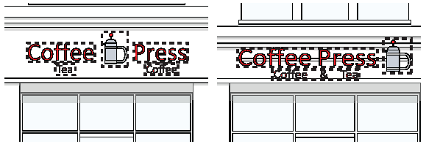

2. For signs on a background, the entire area of the background is calculated as sign area, including any material or color forming the sign face and the background used to differentiate the sign from the structure on which it is mounted. For ground signs, projecting signs, shingle signs, double post signs, single post signs and sidewalk signs, sign area includes the face of the structure that the message is affixed to, not including any supports, bracing or street number.

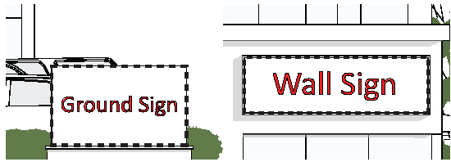

3. For subdivision entrance signs, sign area does not include the wall the sign is located on. Sign area only includes the background designed to hold the sign or in the case of freestanding letters, the total area of the rectangle, circle or square that fully encloses all the letters or logo.



4. The sign area of a three-dimensional sign is calculated as total area of the smallest rectangle, circle or square that fully encloses the largest profile of the three-dimensional sign.

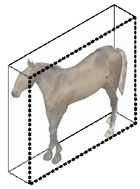

5. The area for a sign with more than one face is computed by adding together the area of all sign faces greater than 60 degrees; if the sign face angle is less than 60 degrees, only the area of the largest sign face is computed as part of the sign area.

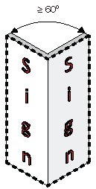

B. **Measurement of Sign Height.** The total height of a ground or post sign is measured from the highest point of the sign or supporting structure to the top of the abutting sidewalk.

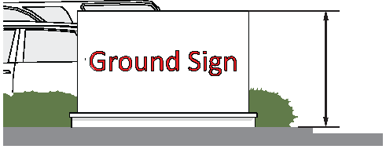

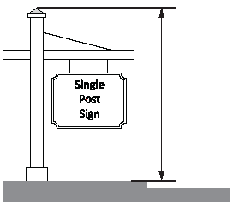

10.3.23. Sign Maintenance

A. All signs must be maintained in good condition and present a neat and orderly appearance. The Zoning Director may cause to be removed after due notice any sign which shows gross neglect, becomes dilapidated, or if the ground area around it is not well maintained.

B. The Zoning Director will give the owner 10 days written notice to correct the deficiencies or to remove the sign or signs. If the owner refuses to correct the deficiencies or remove the sign, the Zoning Director will have the sign removed at the expense of the owner.

10.3.24. Sign Illumination

Illumination of signs must be in accordance with the following requirements.

A. **Prohibited Light Sources.** The following light sources are not allowed:

1. Blinking, flashing and chasing;

2. Bare bulb illumination.

3. Colored lights used in any manner so as to be confused with or construed as traffic control devices.

4. Direct reflected light that create a hazard to operators of motor vehicles.

B. **Brightness.** The light from any illuminated sign cannot be of an intensity or brightness that will interfere with the peace, comfort, convenience, and general welfare of residents or occupants of adjacent properties.

C. **Internal Illumination.**

1. Internally illuminated signs are not allowed in the -HOD district.

2. Channel letters may be internally lit or back-lit.

3. For internally illuminated signs on a background, the background must be a contrasting color.

4. Neon window signs stating "Open" are allowed as specified in Sec. 10.3.7.E.2.

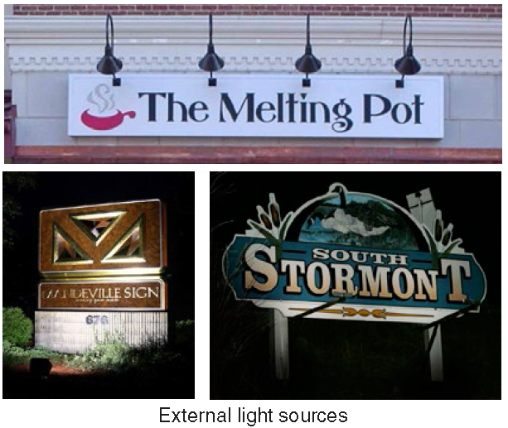



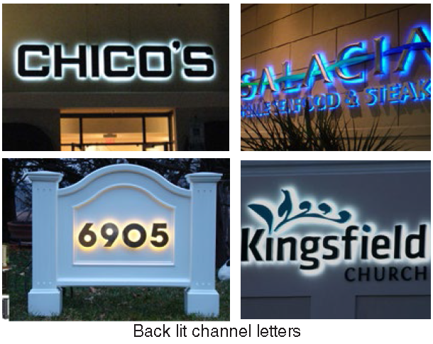

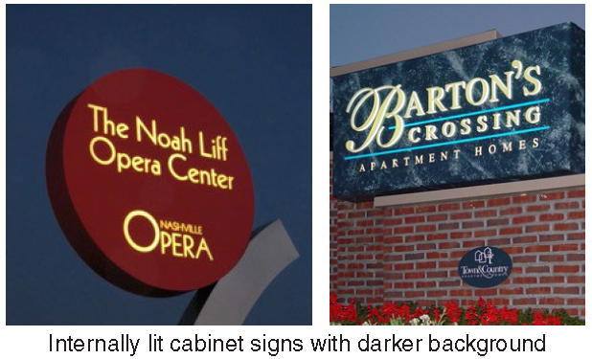

5. The number of neon strokes used in internally illuminated channel letters is based on the width of the letters as follows:

a. 0" to 4" - no more than a single stroke;

b. >4" to 8" - no more than a double stroke; and

c. >8" - no more than a triple stroke.

6. Light emitting diodes (LED)'s are allowed as a light source in a manner that the LED is behind acrylic, aluminum or similar sign face and returns in such a manner that the LED modules are not visible from the exterior of the sign.

D. **External Illumination.**

1. Lighting directed toward a sign must be shielded so that it illuminates only the face of the sign and does not shine directly onto public right-of-way or adjacent properties.

2. Projecting light fixtures used for externally illuminated signs must be simple and unobtrusive in appearance, and not obscure the sign.

E. **Raceways and Transformers.**

1. If a raceway is necessary, it cannot extend in width or height beyond the area of the sign.

2. A raceway must be finished to match the background wall or canopy, or integrated into the overall design of the sign.

3. Visible transformers are not allowed.

10.3.25. Changeable Copy Signs

Changeable copy signs must be in accordance with the following requirements.

A. **Manual changeable copy sign.** A sign or portion of a sign that has a readerboard for the display of text information in which each alphanumeric character, graphic or symbol is defined by objects, not consisting of an illumination device and may be changed or re-arranged manually or mechanically with characters, letters, or illustrations that can be changed or rearranged without altering the face or the surface of the sign.

B. **Signs Allowed.**

1. Manual changeable copy is allowed in conjunction with a permitted ground sign. No electronic changeable copy is allowed.

2. The changeable copy portion of the ground sign can be no greater than 50% of the total sign area, however, in no case can the changeable copy portion of the ground sign exceed 32 square feet in area.

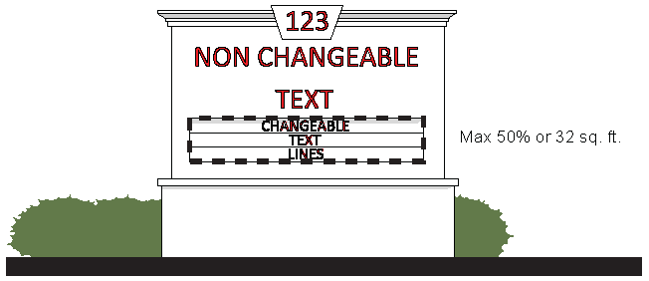

3. Ground signs permitted with the use of a convenience store with fuel pumps are allowed to have changeable copy as provided for by the laws and regulations of the State of Georgia.